**Information**

|  |  |  |
| --- | --- | --- |
| **Report ID** | **Title** | **Workstream** |
| C0526 | Service Repair Labels | Customer Order Management |

**Revision History**

|  |  |  |  |
| --- | --- | --- | --- |
| **Revision** | **Date** | **By** | **Remarks** |
| 1.0 | 26/04/2021 | Duncan Bennett | Base spec |
| 2.0 | 27/04/2021 | Namal Mohottige | Added additional logic |
| 3.0 | 07/007/2021 | Namal Mohottige | Added Test Scenarios and Testing Issues. Also added minor change requests. |
| 4.0 | 14/7/2021 | Duncan Bennett | Updated Testing Issues |
| 5.0 | 16/07/2021 | Namal Mohottige | Updated the Tunstall Warranty section |
| 6.0 | 04/08/2021 | Namal Mohottige | Updated the Tunstall Warranty section – Warranty will be derived from the Sales Part |

# Report Narrative

When a new work order is created for service repair if the product is a dispersed unit, 3 repair labels need printing. If the product is non-dispersed only one repair label is required. The purpose of this specification is to outline the new report layouts. The actual report generation will be handled separately when repair work orders are created in IFS.

Text Font: Headers should use **Calibri Bold (Body)**, all other text font Calibri (Body).

Text colour should be black.

Label details should be listed in a table view.

Label size 54mmX101mm – Dymo Item#S0722430

# Label 1 Service Repair Label

## IFS Report

A new custom operational report will be created to generate the new label.

The system will use the data in Product Repair Booking Tab when the report is generated. The new report will be named as ‘Service Repair Label’. A new Custom RMB will be created from the Prepare Work Order | Product Repair Booking tab to initiate the report.

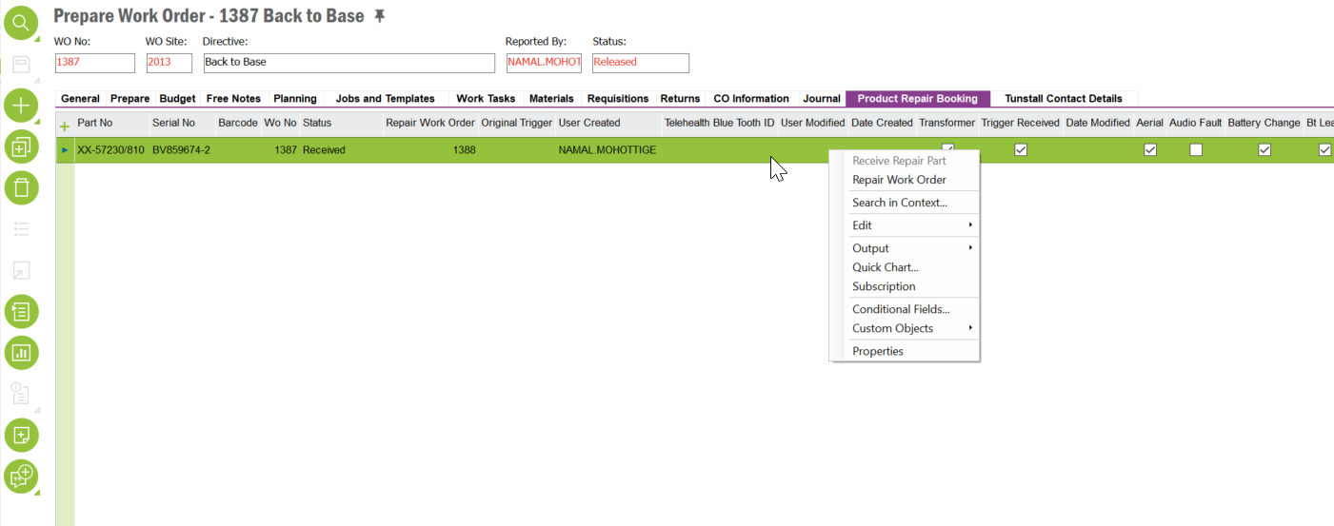

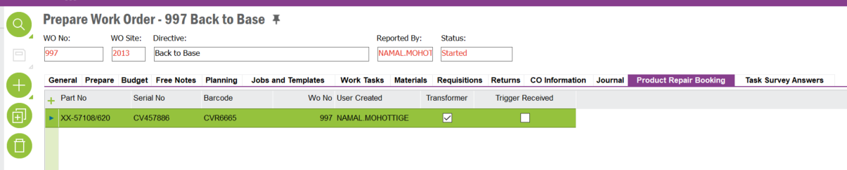

Note: A new report has already been created, it has to be based on the data in the Product Repair Booking. It shouldn’t refer to data in Work Order | Return Tab.

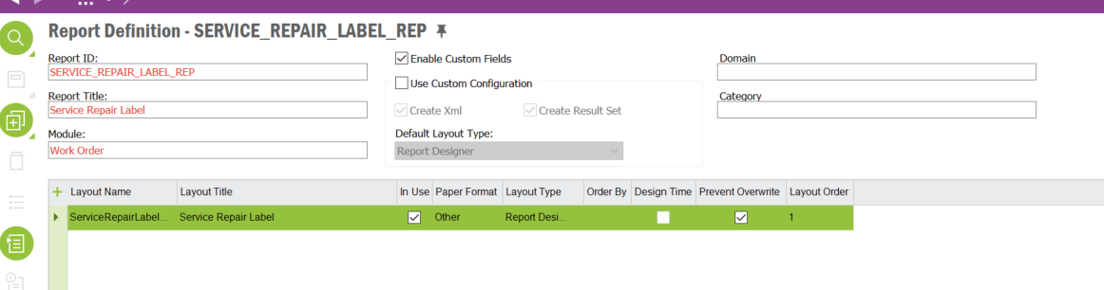

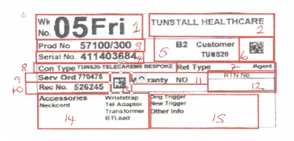

Label 1 Dispersed unit – details captured shows.

## Label size

54mmX101mm – Dymo Item#S0722430

## Label Data Mapping

|  |  |  |  |
| --- | --- | --- | --- |
| LABEL FIELD | IFS MAPPING | Notes | Label Number Mapping |
| WEEK NO | Booked In Date | Needs to be in shown as WK & Day | 1 |
| PROD NO | Part No from Serial/Functional Object | 57100/300 | 3 |
| SERIAL NO | Serial No from Serial/Functional Object | 411403684 | 4 |
| CUSTOMER |  | Customer Name, Account Number | 5 |
| BARCODE | Serial No | Serial No barcode will be created | 6 |
| CON TYPE | Task Template ID of Repair Work Order | First task template will be considered when there are multiple tasks exist | 8 |
| WORK ORDER | Work Order No | Back to Base WO (Parent Work Order No). Will be hardcoded to 999999 when there is no parent work order linked | 9 |
| REPAIR WORK ORDER | Work Order No | Service Repair WO | 10 |
| Bar Code | New | Work order detail captured in Bar Code | 13 |
| RET TYPE | Customer Group Description from Customer | Return Type UK or Export identified by Customer Groups? | 7 |
| WARANTY | Tunstall Warranty Custom Field | Calculation from serial number | 11 |
| RTN NO. |  | Not Required | 12 |
| ACCESSORIES | See the Custom Fields highlighted below | Captures returned accessories listed. Only customer return items will have accessories | 14 |
| ORIGINAL TRIGGER | See the Custom Field highlighted below |  | 15 |
| OTHER INFO | Fault Desc from Prepare Work Order | General Tab |  | 15 |

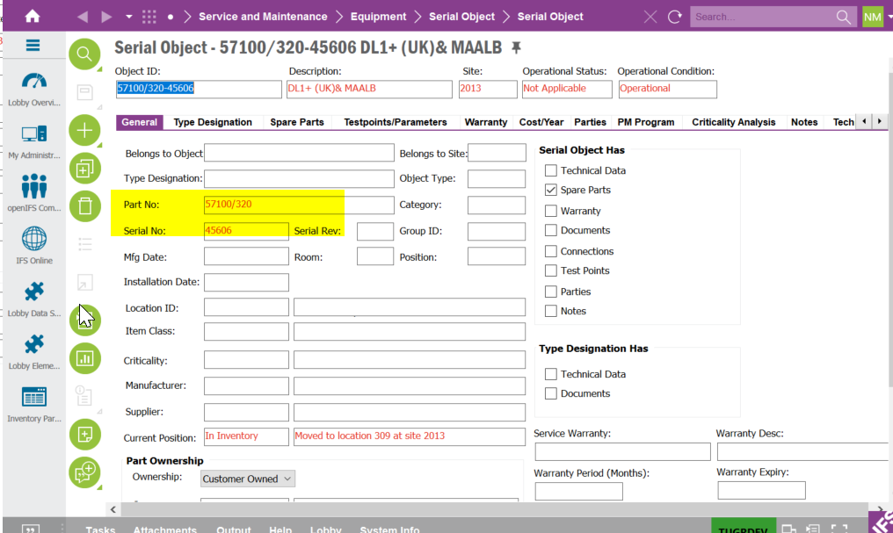

3,4 – Part No and Serial No

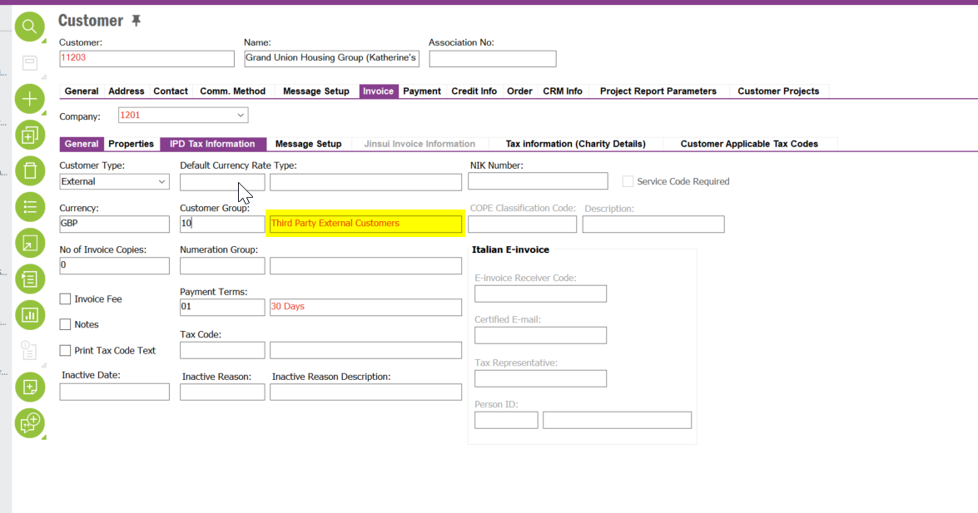

7 – RET TYPE

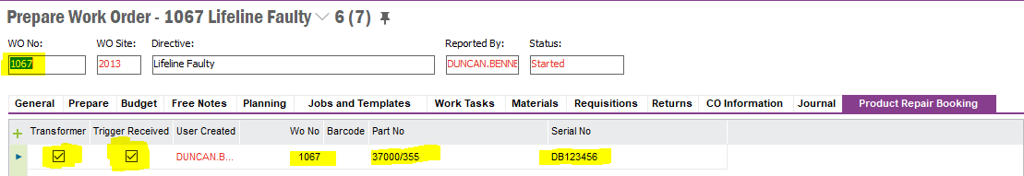

The above screen shot shows numbers covered from the table above No’s 3,4,09

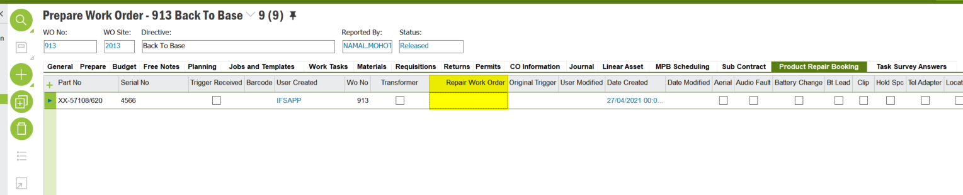

10 – Repair Work Order

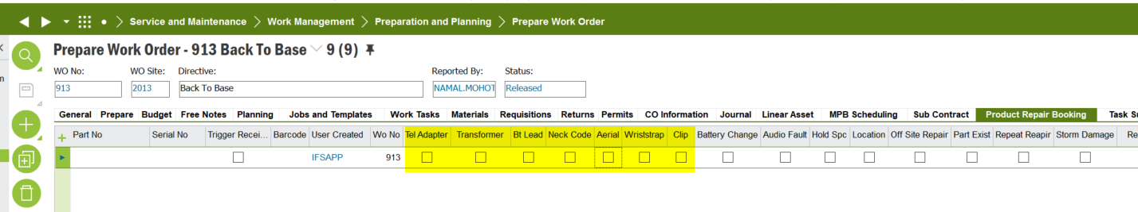

14- If any of the highlighted fields are ticked the system will display those in the label

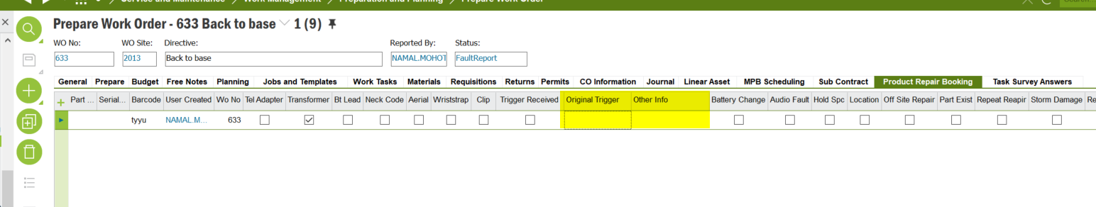

15 – Original Trigger and Other Info

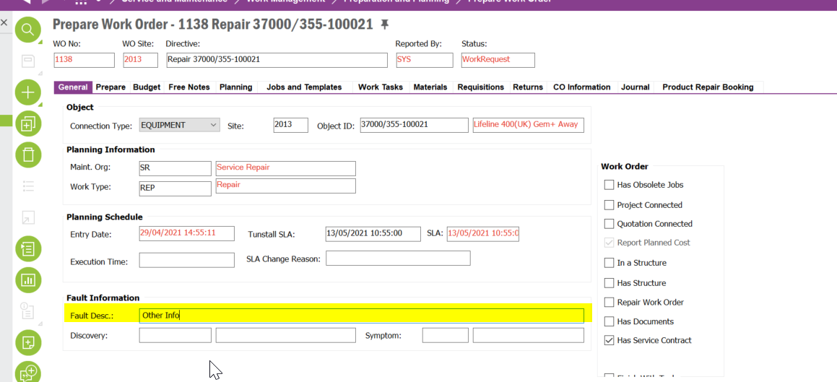

**Other Info**

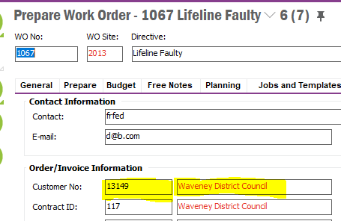

The above screen shot identifies No’s 2,5

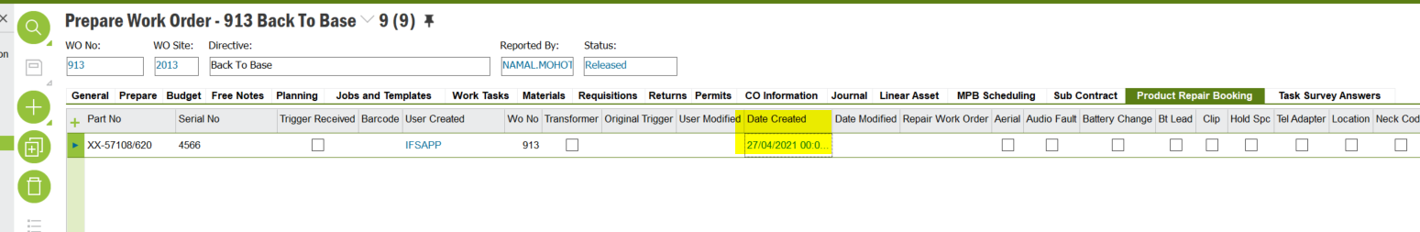

The Booking in date should above be captured and shown as WK and Day No 1 not as shown.

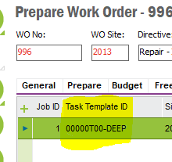

The Contract Type will be captured as above by the task template No 8

# Label 2 Cosmetic Audit

## IFS Report

A new report layout will be created for Work Task Report. The new layout will be named as ‘Cosmetic Audit’. This label will only be printed for dispersed products

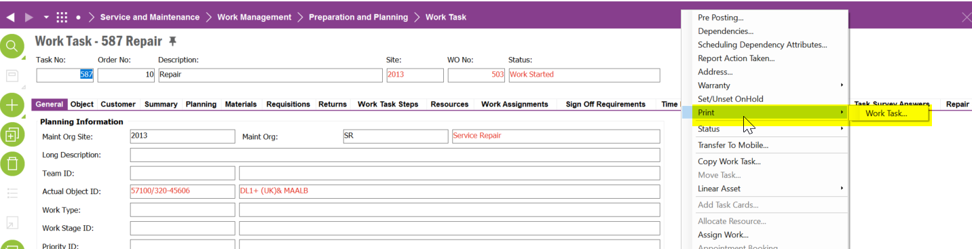

## Label size

54mmX101mm – Dymo Item#S0722430

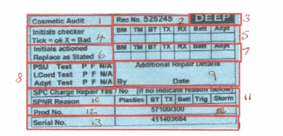

## Label Data Mapping

|  |  |  |  |
| --- | --- | --- | --- |
| LABEL FIELD | IFS MAPPING | Notes | Label Number Mapping |
| Cosmetic Audit |  | This will the Report Title | 1 |
| Repair Wo No. | WORK ORDER NO |  | 2 |
| CLEANING LEVEL | Task Template |  | 3 |
| PROD NO | Part No of Actual Object ID |  | 12 |
| SERIAL NO | Serial No of Actual Object ID |  | 13 |
| Initial Checker | Hardcoded | Tick = Ok, X = Faulty | 4 & 5 |
| Initial Action | Hardcoded | Replace as stated | 6 & 7 |
| PSU Test P F N/A | Hardcoded |  | 8 |
| L Cord Test P F N/A | Hardcoded |  | 8 |
| Adpt Test P F N/A | Hardcoded |  | 8 |
| Additional Repair Detail | Hardcoded | Name Date | 9 |
| SPC Charge Repair Yes / No |  |  | 11 |
| SPRN Reason | Hardcoded |  | 11 |

BM = Bottom Moulding, TM = Top Moulding, BT = BT Lead, TX = Transformer, RX = Receiver,

Bat = Battery, Adpt =Telephone Adaptor

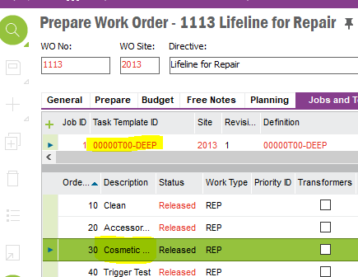

The clean type can be identified from the task template No 3 and the cosmetic header from the task description No 1

****12,13 – Part No and Serial No

# Label 3 – Test Label

## IFS Report

A new report layout will be created for Work Task Report. The new layout will be named as ‘Test Label’. This label will only be printed for dispersed products.



## Label size

54mmX101mm – Dymo Item#S0722430

## Label Layout

|  |
| --- |
|  |

## Label Data Mapping

|  |  |  |  |
| --- | --- | --- | --- |
| LABEL FIELD | IFS MAPPING | Notes | Label Number Mapping |
| Tunstall Test Sheet | Hardcoded | Report Tittle | 1 |
| Repair Wo No | Work Order |  | 2 |
| Test Count | Hardcoded | Rename TTL to 4 | 3 |
| Trigger | Hardcoded |  | 4 |
| Programming | Hardcoded |  | 5 |
| FFT | Hardcoded |  | 6 |
| Post FFT | Hardcoded |  | 7 |
| Operatinal Instruction | Hardcoded | Tick = Ok  Fail= Enter Code | 8 |
| Tec Instruction | Hardcoded | Please indicate repair with R over failed code | 9 |
| Product No | Part No of Actual Object ID |  | 10 |
| Serial No | Serial No of Actual Object ID |  | 11 |

****10,11 – Part No and Serial No

# Tunstall Warranty

A new custom field will be added to Prepare Work Order | Product Repair Booking tab.

Note: Currently this field has been added to the ActiveSeparate Logical Unit. This field will be removed from the ActiveSeparate LU.

| DB Column Name (if known) | Field Label | Insert | Mandatory | Update | Queryable | Zoom | Uppercase | List of Value | Format & Length | Comment and Reference |
| --- | --- | --- | --- | --- | --- | --- | --- | --- | --- | --- |
| TUNSTALL_WARRANTY | Tunstall Warranty | N | N | Y | Y | N | N | N | VARCHAR2(5) | This will a read only tick box. If the product is under Tunstall manufacturer warranty, this box will be ticked |

## Warranty Calculation

The product manufactured year and week will be derived from the Barcode on the Prepare Work Order | Product Repair Booking. The barcode consists of the Part No, Issue No, Manufactured Week/Year and Serial No separated by ‘-‘character. In the example below the manufactured year is 2015 and the week is 09.

37000/355-C1-0915-057208

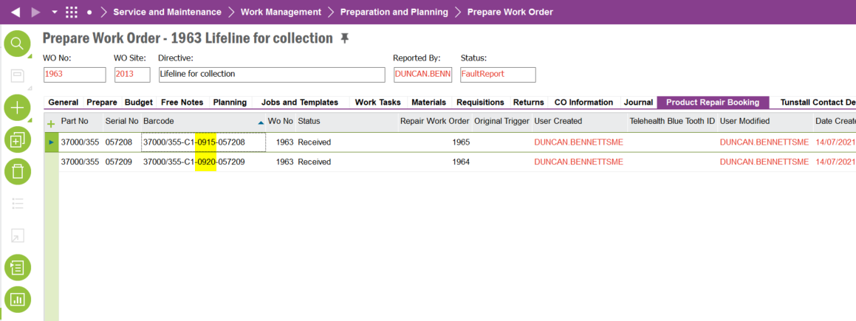

Warranty Duration

The warranty duration will be retrieved from the Sales Part | Customer Warranty. The Max Value and Time unit will be used to calculate the warranty duration. If the warranty is still valid, the system will tick the Tunstall Warranty check box.

For example, if the manufactured week/year is 3419 and warranty duration is 24 months, the system will tick the check box, since the warranty is still valid.

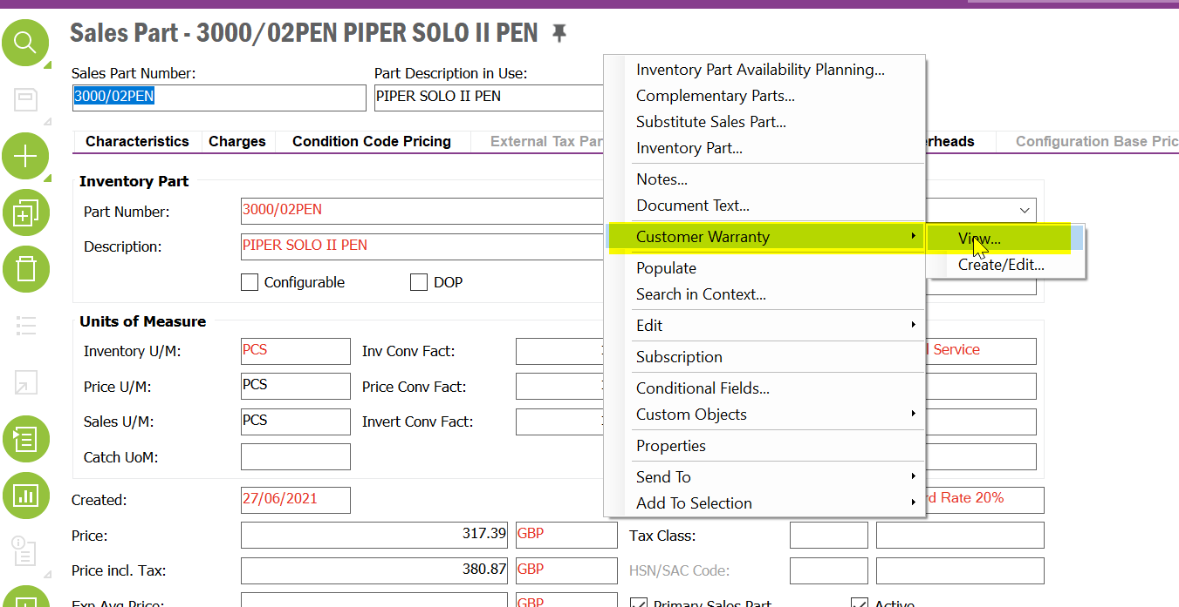

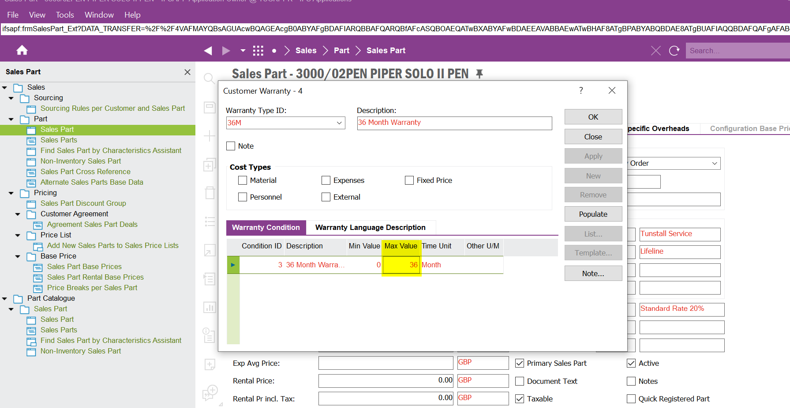

# Test Scenarios

| **Test ID** | **Recommended Test** | **Test Outcome** | **Status** |
| --- | --- | --- | --- |
| 1 | Create a Service Repair Label for a Product Under Warranty |  |  |
| 2 | Create a Service Repair Label for a Product Not Under Warranty |  | Fail |
| 3 | Create a Service Repair Label including accessories |  | Fail |
| 4 | Print the Cosmetic Audit Label from the Cosmetic Task – For Serial Object |  | Fail |
| 5 | Print the Cosmetic Audit Label from the Cosmetic Task – For Functional Object |  |  |
| 6 | Test the Test Label Report |  | Fail |

# Testing Issues

| **Test ID** | **Issue ID** | **Issue Description** | **Status** |
| --- | --- | --- | --- |
| **1** | **1** | **Barcode for the Service is incorrect, It should be the barcode of repair work order. In the following example it should be the barcode of 1388** | **Pass** |
| **1** | **2** | **Con Type is not populated correctly. It should select the task template id from the repair work order. In the above example it should select the task template id from the work order 1388** | **Pass** |
| **3** | **2** | Missing Accessories – The following are missing  Clip  Areal | Pass |
| **2** | **3** | The Warranty flag doesn’t work. It always display ‘Yes’ | **Fail** |
| **4** | **5** | Prod No and Serial No are blank  It should display the Part No and Serial No of the Actual Object ID. Note the actual object could be a Serial Or Functional Object. | **Pass** |
| **4** | **6** | This is a request:  Rec No. should be changed to Repair Wo No.  And it should display the Work Order No instead of Task No | **Pass** |
| **6** | **7** | The Prod No. and Serial No are not populated |  |
| **6** | **8** | There is a typo (see the highlighted line), it should be Enter Code | **Pass** |
| **6** | **9** | This is a change request- The Rec No. label should be changed to Repair Wo No. | **Pass** |

# New Issues Identified 14/7/21

| **7** | **1** | The product number is not being correctly displaid    The part number should be 37000/355 as per the example below. |  |
| --- | --- | --- | --- |
| **7** | **2** | The serial number is not being correctly displaid    The serial number on the example used is shown below    Note the serial number and product number are identified from the serail object |  |
| **7** | **3** | The warranty does not update when the product is not in warranty    The warranty calculation is derived from the WW/YY shown on the below screen shot. The week Year is part of the bar code identified below. Line one in this instance would be out of warranty, line 2 would be in warranty.  Please refer to the Tunstall Warranty Calculation section |  |
|  |  |  |  |

**Technical Implementation**

Outcome of the CRIM is three reports  
  
Service Repair Label  
  
Accessed from “Product Repair Booking” Tab of Prepare Work Order window

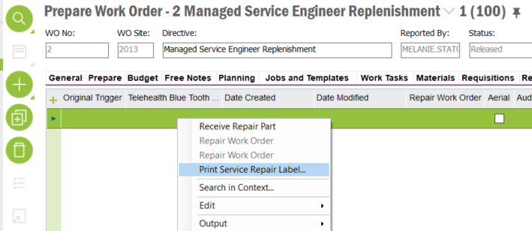

Test Label & Cosmetic Audit Label  
  
Accessed from “Print Work Task” RMB of Work Task/Work Tasks windows  
  
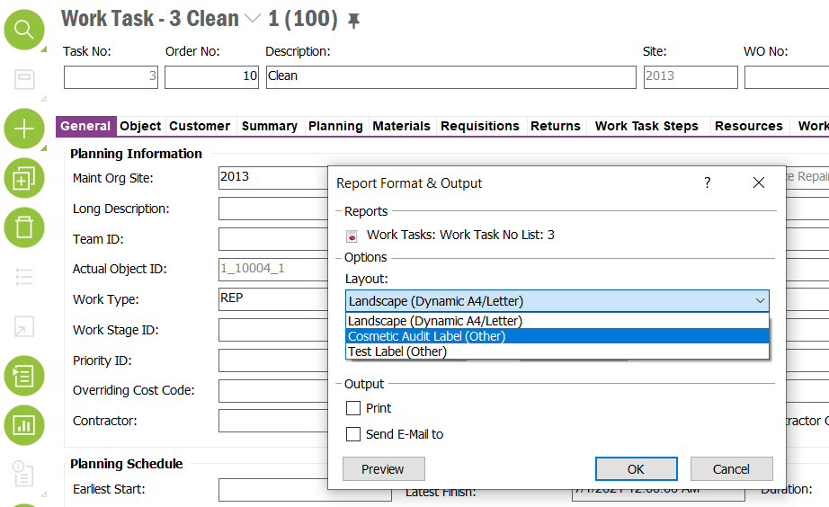

Custom Fields  
  
Following three custom fields are used by the report layouts  
  
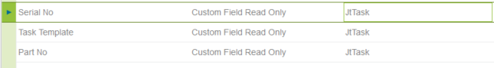

Note: This CRIM also depends on the objects delivered by CRIM C0535.